<석사>
재료과학

김영도교수님

영문ver.
1. Suppose that the shape of nucleus is in the form of cubic shape not in the form of spherical shape during the nucleation, describe the formula about a*(Critical size) and △G* with using γ(Surface free energy) and △g_{v}(volume energy). The length of one side of the cubic is a.

2. ThinAl foil was heated up to melting point and quenched to ambient temperature. If the formation energy for one vacancy is 1.5eV, calculate the vacancy concentration of the thin Al foil. When the thickness of the foil is increased, what is the difference in number of vacancy? Suppose that the quenched foil is annealed at 90ºC, what is the difference in number of vacancy and what is the meaning of aging temperature?

3. Pure Cu sheet was fabricated by rolling to examine the recrystallization behavior. The specimen designated A was obtained by rolling at Monday. 4 days later, the specimen designates as B was also obtained by rolling with the same reduction ratio. On Friday, specimen A and specimen B were simultaneously annealed just after the rolling of specimen B. What is the difference in recrystallization behavior between specimen A and specimen B?

기존ver.
1. 상변태에 따른 핵생성 시 핵의 모양이 구형이 아닌 정육면체의 형태로 생성된다고 한다면 이때 정육면체의 한변을 a라고 한다면 a*(critical size) 및 △G*를 γ(surface free energy)와 △g_{v(}(volume energy)항으로 나타내라.

2. 얇은 Al 시편을 융점까지 온도를 올린후 상온으로 급냉하였다. 하나의 vacancy를 생성하는 에너지가 1.5eV라고 하면 급냉한 시편의 vacancy의 농도는 얼마인가? (pre-exponential 상수는 1이며 Boltzmann 상수 k=8.625x10⁻⁵eV/deg) 또한 시편의 두께를 두껍게 하면 vacancy수는 어떻게 달라질까? 만일 급냉한 시편을 90℃로 온도를 올려 annealing 하면 vacancy수는 어떻게 되며 이러한 aging 온도는 어떤 의미가 있는가?

3. 순수한 구리를 압연(rolling)하여 판재(sheet)로 제조하여 재결정거동을 실험하고 있다. 월요일에 압연을 하여 A라는 판재를 얻었고 4일후 금요일에 압연을 하여 B라는 판재를 얻었다. 이때 A, B 모두 같은 조건의 압하율(reduction ratio)로 압연을 하였다. 이 두 시편을 금요일 B시편을 얻은 직후에 annealing을 행하였다면 이들 시편의 재결정거동에는 어떤 차이가 있을까?

전형탁교수님
1 번 문제
Below 24.5 K, Ne is a crystalline solid with an FCC structure. The interatomic interaction energy per atom can be written as
$E(r)=−2ε\left[\text{14}\text{.}\text{45}{\left(\frac{σ}{r}\right)}^{6}−\text{12}\text{.}\text{13}{\left(\frac{σ}{r}\right)}^{\text{12}}\right]$ (eV/atom)
where ε and σ are constants that depend on the polarizability, the mean dipole moment, and the extent of overlap of core electrons. For crystalline Ne, ε = 3.121 × 10⁻³ eV and σ = 0.274 nm.
a. Show that the equilibrium separation between the atoms in an inert gas crystal is given by r_{o} = (1.090)σ. What is the equilibrium interatomic separation in the Ne crystal?
b. Find the bonding energy per atom in solid Ne.
c. Calculate the density of solid Ne (atomic mass = 20.18).
For the Ne crystal, σ = 2.74 × 10⁻¹⁰ m and ε = 0.003121 eV, 1eV=1.6x10⁻¹⁹J

2 번 문제
Draw or indicate (a) basis (b) primitive cell (c) lattice translation vector of below two dimensional crystal structure.
(아래 좌측에 있는 2차원 결정구조의 (a) basis (b) primitive cell 과 (c) lattice translation vector를 표시하라.)

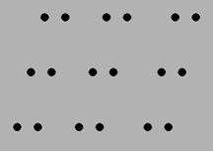

안진호교수님

영문ver.
(1) Explain the difference in the 'dependence of electrical resistivity on temperature' between metals and semiconductors.

(2) Explain why some materials show 'Piezo electricity', and mention as many applications of Piezo electricity as possible.

기존ver.
(1) 온도에 따른 전기저항의 변화가 금속과 반도체에 대해 어떻게 다른지 비교 설명하라.
(2) 물체가 압전성 (Piezo electricity)을 가지는 이유에 대해 설명하고, 압전체의 응용 예를 들어라.

윤종승교수님

- Germanium in single crystal form is found to contain 0.0007 at% of Ga as a dopant element. (Band gap for Ge = 0.7 eV)
- Draw the band structure including the valence and conduction band and impurity band levels.
- Determine the free charge carrier type and concentration.
(density for Ge = 5.32 g/cm³, A.W. for Ge = 72.59 g/mol)

- Nickel has an atomic weight of 58.7 and a density of 8.94 g/cm³.
- What is the number of nearest neighbors?
- Give the location indices of any two of the nearest neighbors.
- What is the second nearest neighbor in units of Å?

김현우교수님

- Show that the spacing between (hkl) planes in the cubic system d_{hkl} is given by d_{hkl} = a/(h² + k² + l²)^{1/2}, where a is the lattice parameter.
- Calculate the stress necessary to move a dislocation through a matrix containing a fine dispersion of second-phase particles where the average spacing between the surfaces of adjacent particles is 400Å. Take G=10¹¹ dynes/cm² and b= 2x 10⁻⁹ cm.
- Show that a dislocation in a BCC structure with a Burgers vector equal to a<110> is energetically unstable and will split into two (a/2)<111> dislocations by the following reactions:

a[110] → (a/2)[111] + (a/2)[1]

박진성교수님

영문 Ver.

1. SrTiO3 has the cubic perovskite structure, a=0.391 nm, with atomic coordinates:
Sr: 1/2 1/2 1/2, Ti: 0 0 0, O: 1/2 0 0, 0 1/2 0, 0 0 1/2.
(a) Draw a projection of the structure on the x-z plane.
(b) Calculate the Sr-O and Ti-O bond lengths. Calculate the density of SrTiO3.
(c) What compositional modifications may be made to SrTiO3 in an attempt to induce (i) ferroelectricity (ii) superconductivity (iii) ionic conductivity.

한글 Ver.
- SrTiO3는 Cubic Perovskite 구조이며 격자거리 a= 0.391 nm 이다.
Sr: 1/2 1/2 1/2, Ti: 0 0 0, O: 1/2 0 0, 0 1/2 0, 0 0 1/2.
(a) x-z 평면에 구조를 투사하여 그리세요.
(b) Sr-O와 Ti-O의 결합 거리를 계산하고 SrTiO3의 밀도를 계산하세요.
(c) (i) 강유전성 (ii)초전도 (iii) 이온전도도를 유도하기 위하여 SrTiO3를 제조할 때 각각 어떤 조성의 변화를 만들어야 하는지 설명하시요.

오누리교수님

Surface atoms have missing bonds and depending on the crystallographic plane of the surface, the number of missing bonds per atom will be different. For the {100}, {110}, and {111} planes of an FCC crystal, calculate the ratio of missing bonds per unit area and determine which plane will have higher surface energy.

임원빈교수님

- The potential energy between two simple, neutral molecules at a separation r is given by
$U(r)=−\frac{{\text{Aa}}_{0}^{6}}{r^{6}}+\frac{{\text{Ba}}_{0}^{\text{12}}}{r^{\text{12}}}$
By obtaining an expression for the force, determine the relationship between the constants A and B (r = a₀, which is the equilibrium distance).

- The potential energy can also be written in an alternative form:
$$U(r)=4ε\left[{\left(\frac{σ}{r}\right)}^{\text{12}}−{\left(\frac{σ}{r}\right)}^{6}\right]$$
Calculate σ from the equation and what means ε in this solution? The r = a₀, which is the equilibrium distance.

최선진교수님

Problem 1

Answer the following questions about the atomic packing factor.
- Explain the definition of the atomic packing factor (APF)?
- Calculate the atomic packing factors of FCC and BCC.
- Demonstrate the atomic packing factor for HCP is the same with FCC.
- The density of metals can be expressed by the following equation:
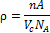
, where n = number of atoms/unit cell
A = atomic weight
V_{C} = Volume of a unit cell
N_{A} = Avogadro’s number (6.022 × 10²³ atoms/mol)
Calculate the atomic packing factor of tin (Sn) when Sn has density, atomic weight, and atomic radius of 7.27 g/cm³, 118.71 g/mol, and 0.151 nm, respectively. Assume that the unit cell of Sn is tetragonal symmetry with a and b lattice parameters of 0.583 and 0.318 nm.

<석사>
열역학

정용재교수님

영문ver.
1. If we wished to evaluate the internal energy U in terms of the independent variables T and P, we could write the differential equation as follows.

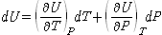

Evaluate the partial derivatives in this equation in terms of experimentally convenient variables.

기존ver.
1. 내부에너지 U를 온도와 압력으로 표현하고자 하면, 다음과 같은 식을 생각해 낼 수 있다.

위의 식에서 partial derivatives 들을 experimentally convenient variables로 표현해 보아라.

신동욱교수님

영문ver.
1. Explain briefly the concept of entropy and interpret the physical meaning of the second law of thermodynamics based on the entropy concept.
2. Write down Enthalpy H expression as a function of Internal energy U, explain the difference between these two quantities. Explain the condition H or U is used. Using these quantities, explain the difference between constant volume heat capacity C_{v} and constant pressure heat capacity Cp.

3. Explain the Ehrenfest criterion of phase transformation. Draw schematically the graphs and explain briefly the change in volume, Enthalpy, Chemical potential, Entropy, and Heat capacity during the phase transformation.

기존ver.
1. Entropy 개념에 대하여 개괄적으로 설명하고 이를 이용하여 열역학 제 2 법칙의 물리적 의미에 대하여 설명하시오.

2. Enthalpy H의 식을 Internal energy U의 함수로 표현하고 이들 두 에너지 값의 차이점을 설명하라. 어떠한 조건에서 H 혹은 U를 쓰는 지 설명하고 이를 Heat capacity C_{v}와 Cp의 차이점을 설명하는데 이용하여 이들 두 Heat capacity의 차이점을 설명하라.

3. 상변이의 유형을 분류하는 기준인 Ehrenfest criterion을 설명하고 이를 이용하여 상변이 온도에서 나타나는 Volume, Enthalpy, Chemical potential, Entropy, Heat capacity의 변화를 상변이 유형별로 그래프로 그려 비교, 설명하라.

장재일교수님

- Explain what are wrong at each point (A, B, C) in the phase diagram shown below, and correct them. Also, show what reactions will occur in the corrected parts. Note that corrected A part should have at least two invariant points.
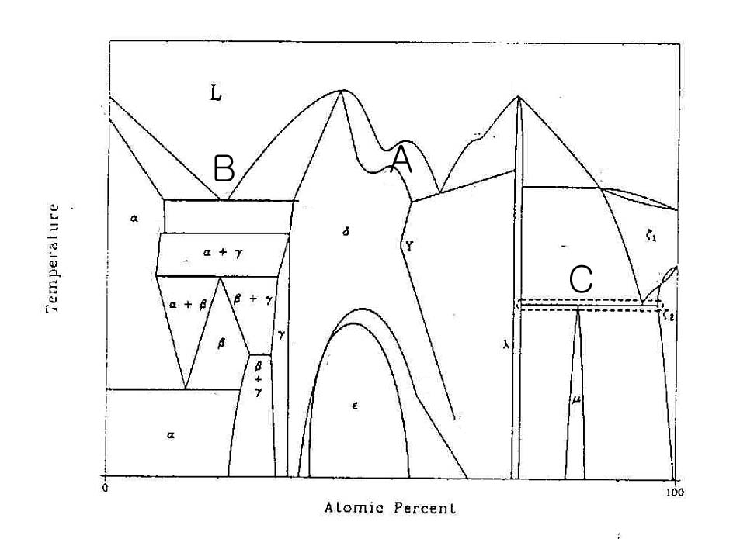

- In a A-B binary alloy system, pure metals A and B have a fcc structure. If liquid phase is approximately ideal (i.e., randomly mixed), (1) draw typical “equilibrium phase diagrams” for following cases and (2) explain how you could obtain the diagrams (based on “Gibbs free energy vs. composition curves” of the liquid and solid phases at various (more than 4) temperatures).
(a) E_{AB} = (E_{AA} + E_{BB})/2 (b) E_{AB} > (E_{AA} + E_{BB})/2 (c) E_{AB} >> (E_{AA} + E_{BB})/2
(where E = bonding energy in solid)

정두석교수님
영문 ver
1. Prove that the maximum work for an ideal gas in contact with heat reservoir is only achieved from reversible processes.

국문 ver
1. 열원와 접촉하고 있는 이상기체의 경우를 예를 들어 가역적 상태변화가 최대의 일을 수행할 수 있음을 증명하시오.

이승용교수님

- Here is a completely different universe where the thermodynamic laws are still valid but follows , , and . Please derive an expression for reversible adiabatic processes, for the relationship between P and V in this new universe.

- For each component i in a mixture of ideal gases, the chemical potential for i is related to the partial pressure as . From this, please derive an expression for the molar Gibbs free energy of mixing of ideal gases for A, B, C, .

이종원교수님

(1) The following diagram represents the Carnot cycle.
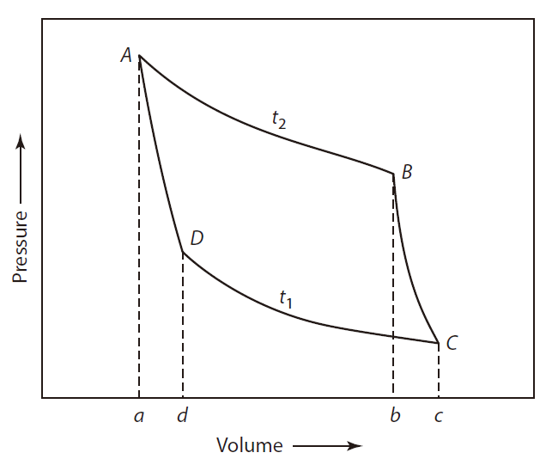
- Demonstrate that the work done by the A → B process exceeds that done by the B → C process.
- Provide a qualitative explanation on this phenomenon.

(2) As a preliminary formulation of the Second Law of Thermodynamics, the principle of Clausius mentions that it is impossible to transfer thermal energy from a cold to a hot reservoir without, in the same process, converting a certain amount of work to thermal energy. Demonstrate that on the basis of this principle, the Carnot cycle is the process with a maximum efficiency.
<석사>
금속재료

김영도교수님

영문ver.
1. In the FCC structure, a perfect dislocation having b=1/2<110> resolves into two glissile partial dislocations. Show how the perfect dislocation resolves in (111) plane. Explain the reason why the partial dislocation is more stable than the perfect dislocation. Also, explain the reason why the ribbon of stacking-fault is formed after the dissociation of a perfect dislocation.

2. What is hardenability and how to measure it?

3. The thin iron sheet is in contact with a carburizing gas on one side and a decarburizing gas on the other side at the temperature of 1000ºC. Sketch the resultant carbon concentration profile when a steady state has been reached assuming that the surface concentrations are maintained at 0.15 and 1.4 wt.% C, respectively. If Dc increases from 2.5×10⁻¹¹m²/s at 0.15% C to 7.7×10⁻¹¹m²/sat 1.4% C what will be the quantitative relationship between the concentration gradients at the surface?

기존ver.
1. 결정구조가 fcc인 crystal에서 b=1/2<110>인 perfect dislocation은 두 개의 glissile partial dislocation으로 분해된다. (111)면에서 실제로 분해되는 것을 보여주고 이러한 partial dislocation이 perfect dislocation에 비해 더 안정한지를 설명하라. 또한 dislocation이 분해되면 ribbon of stacking-fault가 생기는데 그 이유를 설명하라.

2. 경화능(hardenability)이란 무엇이며 어떻게 측정하는가?

3. 박판으로 된 철이 1000℃에서 한쪽 면은 침탄가스와 다른 면은 탈탄가스와 각각 접하고 있다. 표면의 농도가 각각 0.15, 1.4wt.% 탄소로 유지된다고 가정하면 정상상태에서 탄소 농도에 대한 profile을 그려라. 또한 D_{c}가 0.15%C에서 2.5 x 10⁻¹¹m²/s인 것이, 1.4%C에서는 7.7 x 10⁻¹¹m²/s로 증가된다면 표면에서의 농도구배사이의 정량적인 관계는 어떻게 되는가?

박원일교수님

영문ver.
1) Schematically illustrate the plot showing the curves for nucleation rate ( ), growth rate ( ), and overall transformation rate versus temperature.

2) Cite advantages and disadvantages of hot working and cold working.

3) In classical theory of homogeneous nucleation, the total free energy change ( ) is based on an energy balance between the volume and surface free energy contributions;
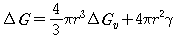
( : free energy difference between the solid and liquid phase or the volume free energy; : the surface energy per unit area of the nucleus)
(a) Derive an expression for , acritical free energy for homogeneous nucleation, as a function of and ∆G_{v}.
(b) In heterogeneous nucleation, , critical free energy for homogeneous nucleation is a function of S(θ) as follows: . Here, S(θ) has the value in the range of 0–1. Explain the reason with the physical meaning.
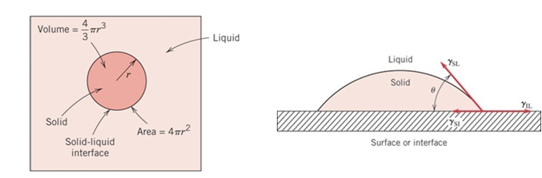
(a) homogeneous nucleation (b) heterogeneous nucleation

장재일교수님

- Draw a typical “shear” stress vs. “shear” strain curve obtainable during a tensile (or compressive) test of a fcc “single” crystal, and explain the reason of its slope change. (Note that there are four different regimes in the curve)

- Draw the phase diagram for Fe-Fe₃C metastable system and describe what three invariant points are.

- “Spherical” solid Cu nuclei is just transformed from liquid Cu and now existing in the liquid. Derive the critical supercooling which makes it possible for the Cu nuclei to grow, if diameter of the nuclei is (a) 2 um and (b) 2 nm. (The properties of Cu is as follows; Tm = 1357.6 K, Atomic Weight = 63.546, Density = 8.96 g/cm³ , γ = 0.177 J/m² , latent heat of fusion = 13,300 J/mol).

윤종승교수님

- It was required to limit grain size during high temperature processing of aluminum sheet. The materials engineer recalled that fine particles tended to limit grain growth, and that finer particles were most effective. The engineer decided that the finest possible particle was single atoms, so introduced 0.1 at.% solute, rather that 0.1 vol% particles.
- Is this approach likely to be effective? Why or why not?
- Compare the effects of solute and particles on high temperature grain growth.

- Solution strengthening is one of the four basic strengthening mechanisms. Describe how this mechanism works. Some solutes are far more effective strengtheners than others. Explain why this is so.

- A cubic metal, placed under tensile stress, is found to exhibit slip between {111} planes. This same metal yields only one diffraction peak at 170º in a Debye-Scherrer experiment when studied with with ScK_{α} radiation. What is the atomic radius of the metal? (λ for ScK_{α} = 3.04 x 10⁻¹⁰m)

한정호 교수님
한글 version
1. 치환형 전율고용체 (Homogeneous substitutional solid solution)을 만들기 위한 Hume-Rothery rules를 설명하시오.
2. Critical Resolved Shear Stress (CRSS)의 물리적 의미에 대하여 그림과 수식을 이용하여 설명하시오.
3. 하기 상태도의 조성 (1, 2, 3)에서, 응고 과정 도중 온도 vs 시간 그래프를 그리시오 (그래프에 상변화가 표기되어 있어야 함).
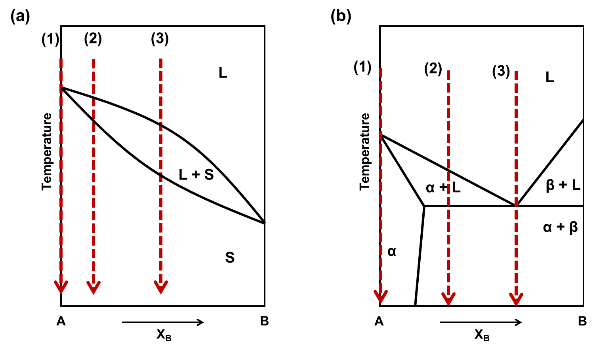

영문 version
1. Explain the Hume-Rothery Rules for homogeneous substitutional solid solution.
2. What is the physical meaning of critical resolved shear stress (CRSS)? Please derive the CRSS using schematic diagram and equations.
3. Given the compositions (1, 2, 3) in the phase diagram, can you plot the temperature vs. time graphs during the solidification process? Ensure that the phase changes are clearly depicted on the graph.

이승용교수님

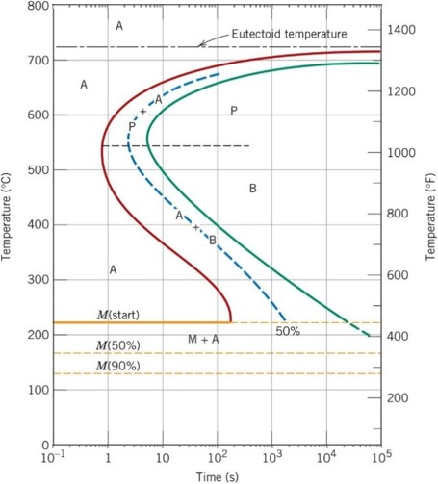
1. Using the isothermal transformation diagram for an iron–carbon alloy of eutectoid composition on the right side, specify the nature of the final microstructure (in terms of microconstituents present and approximate percentages of each) of a small specimen that has been subjected to the following time–temperature treatments. In each case assume that the specimen begins at 760°C (1400°F) and that it has been held at this temperature long enough to have achieved a complete and homogeneous austenitic structure. Please specify the reasons on each answer.
(a) Cool rapidly to 700°C (1290°F), hold for 10⁴ s, then quench to room temperature.
(b) Rapidly cool to 600°C (1110°F), hold for 4 s, rapidly cool to 450°C (840°F), hold for 10 s, then quench to room temperature.
(c) Cool rapidly to 450°C (750°F), hold for 200 s, then quench to room temperature.
(d) Rapidly cool to 575°C (1065°F), hold for 20 s, rapidly cool to 350°C (660°F), hold for 100 s, then quench to room temperature.

<석사>
세라믹재료
정용재교수님

영문ver.
1. Show that equilibrium Shottky defect concentration(or equilibrium Frenkel defect concentration) for ionic system can be represented as follows.
2. Consider the compound TiO₂:
Write the defect relations, including the mass action relations, describing nonstoichiometry in this system. You may assume ionic disorder is limited to the cation sublattice, all defects are fully ionized and it is doped with Nb.

기존ver.
1. 적절한 가정을 통해 ionic system에서 평형 Schottky 또는 Frenkel defect의 농도 n 이 다음과 같이 표현됨을 유도하시오.

2. 임의의 금속 M의 산화물인 M₂O₅를 doping한 TiO₂ 시스템에서 가능한 결함 반응식(defect relation)들과 각각의 결함 반응식에 해당하는 mass action relation들을 작성하여라. (이때 ionic disorder는 양이온의 sublattice에 국한해서 일어나며 모든 결함(defect)들은 fully ionized 되어있는 경우를 가정하고, 필요한 상수들은 임의로 정의하여도 좋음.)

신동욱교수님

영문ver.
1. To describe the glass transition behavior, V-T diagram is normally used. Draw typical V-T diagram for an oxide glass in the case of the glass transition and the crystallization. Explain why the glass transition is not the thermodynamic phase transformation.

2. Draw schematically optical absorption spectrum of typical dielectrics, semiconductors, and metals as a function of frequency. Explain the absorption mechansims in the infrared, UV/Visible, and X-ray ranges.

기존ver.
1. To describe the glass transition behavior, V-T diagram is normally used. Draw typical V-T diagram for an oxide glass in the case of the glass transition and the crystallization. Explain why the glass transition is not the thermodynamic phase transformation.

2. 재료에서 발생하는 빛의 흡수에서 흡수계수의 개형을 주파수의 함수로 그리고 그 메커니즘을 적외선, 가시광선/자외선, X-선 영역으로 대별하여 설명하라.

최창환 교수님

- A Soda-lime-silica glass used to make lamp bulbs has an annealing point of 514˚C and a softening point of 696˚C. Calculate the working range and the melting range for this glass.

- Common soda-lime-silica is made by melting together Na₂CO₃, CaCO₃, and SiO₂. The carbonates break down, liberating CO₂ gas bubbles that help to mix the molten glass. For 1000 Kg of container glass (15 wt% Na₂O, 10 wt% CaO, 75 wt% SiO₂), what is the raw material batch formula (weight percent of Na₂CO₃, CaCO₃, and SiO₂)?

박진성교수님

영문ver.
- Using the Kapustinksii equation and the born-Haber cycle with the following data for MgO (in KJ/mol), estimate the electron affinity for oxygen (O/O²⁻):
[MgO info., KJ/mol] Sublimation of Mg = 148, Ionization Potential of Mg/Mg²⁺ =2188, Dissociation of O₂ = 498, ΔH_{f,MgO}= - 602 , R_{Mg}²⁺ = 0.86 Å, R_{O}²⁻ = 1.26 Å, v: # of ions per formula unit.
Kapustinskii equation:

한글ver.
- Kapustinskii equation과 Born-Haber cycle, 그리고 아래의 MgO (in KJmol⁻¹) 정보를 활용하여 oxygen (O/O²⁻)의 electron affinity 에너지를 구하시오. (20 점).
[MgO 정보, KJ/mol] Sublimation of Mg = 148, Ionization Potential of Mg/Mg²⁺ =2188, Dissociation of O₂ = 498, ΔH_{f,MgO}= - 602 , R_{Mg}²⁺ = 0.86 Å, R_{O}²⁻ = 1.26 Å, v: # of ions per formula unit.
Kapustinskii equation:

정두석교수님

영문 ver
1. Derive the Debye length for a ceramic material including oxygen vacancies (density c_{V}).

국문 ver
1. 공간밀도 c_{V}의 산소공공을 포함하고 있는 세라믹 재료의 Debye length를 유도하시오.

오누리교수님

Explain what Ostwald ripening is and why and how the resulting size distribution changes, assuming the initial size distribution of ceramic particles is symmetric.

최선진교수님

Problem 1
- Calculation of the cation-to-anion radius ratio is a useful method to anticipate the coordination number of ceramic materials according to Pauling’s rules. Demonstrate how ceramic materials with the cation-to-anion radius ratio in the range of 0.225–0.414 have the coordination number of 4.
- Anticipate the coordination number of the ZnS (Zinc blende) structure. Ionic radii for Zn and S are 0.074 and 0.190 nm, respectively. What type of interstitial site that Zn can reside?

Problem 2
List four requirements for the complete solid solution in ceramic materials. (5 points)

Problem 3
List and explain three types of scattering phenomena affecting electron mobility.
이종원교수님

(1) The following diagram illustrates the crystal structure of spinel-type MgAl₂O₄.
(a) Determine the number of octahedral and tetrahedral sites per unit cell created by oxygen.
(b) Describe the key structural features of normal spinel.

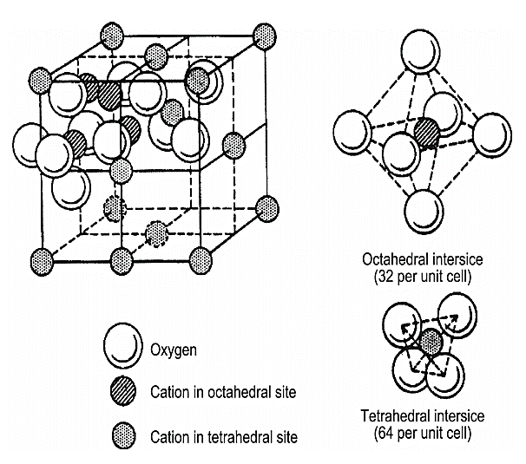
<석사>
기능성재료

안진호교수님

영문ver.
(1) Explain the difference in permitted electron energy distribution between the isolated atoms (infinite atomic spacing) and solid atoms (small atomic spacing).

(2) N⁺-P junction has been fabricated with silicon with doping concentrations of N_{d} = 2 × 10¹⁷ cm⁻³ and N_{a} = 5 × 10¹⁵ cm⁻³ for n and p, respectively. Assuming kT = 0.026 eVand n_{i} = 10¹⁰ cm⁻³, draw energy band diagram with proper energy scale.

기존ver.
(1) 격리된 단원자내의 (atomic spacing이 무한대인) 에너지 구조와 고체를 이루고 있는 (atomic spacing이 작은) 원자의 에너지 구조는 어떻게 다른지 설명하라.

(2) Silicon으로 N_{d} = 2 × 10¹⁷ cm⁻³, N_{a} = 5 × 10¹⁵ cm⁻³인 N⁺-P junction을 만들었다. kT = 0.026 eV, n_{i} = 10¹⁰ cm⁻³ 이라 할 때 energy band diagram을 정량적으로 sketch하라.

전형탁교수님
1번문제
a. Given the Si lattice parameter a = 0.543 nm, calculate the number of Si atoms per unit volume, in nm⁻³.( atomic mass M_{at} = 28.09 × 10⁻³ kg/mol. N_{A}=6.022x10²³/mol)
b. Calculate the number of atoms per m² and per nm² on the (100), (110) and (111) planes in the Si crystal as shown on Figure 1. Which plane has the most number of atoms per unit area?
c. The density of SiO₂ is 2.27 g cm⁻³. Given that its structure is amorphous, calculate the number of molecules per unit volume, in nm⁻³. Compare your result with (a) and comment on what happens when the surface of an Si crystal oxidizes. The atomic masses of Si and O are 28.09 and 16, respectively.
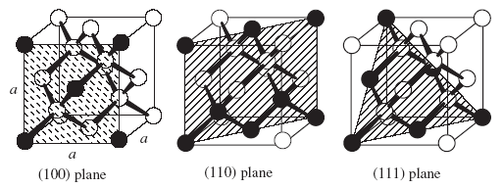
Figure 1: Diamond cubic crystal structure and planes. Determine what
portion of a black-colored atom belongs to the plane that is hatched.

2번 문제
Indicate the (a) basis (b) number of lattice point and (c) which Bravais lattice these two structures belong.
(아래 두 결정구조의 (a) basis와 (b) lattice point 수 그리고 (c) Bravais lattice의 결정구조 분류에 의하면 어디에 속하는지 각각 쓰시오.)
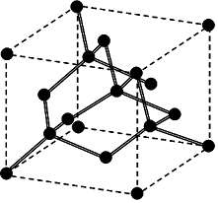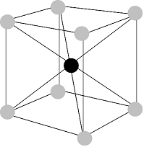

박원일교수님

기존ver.
1) Explain the reason why most of solid materials expand upon heating by considering the relationship between the potential energy and interatomic distance.

2) Plot the Flux density B versus the magnetic strength H for diamagnetic, paramagnetic, and ferromagnetic materials with respect to Vacuum.

3) Briefly explain why metals are opaque to electromagnetic radiation having photon energies within the visible region of the spectrum.

박진성교수님
- Which of the following doped semiconductors will be p-type and which will be n-type? (a) arsenic in Germanium (b) germanium in Silicon (c) indium in germanium (d)silicon on antimony site in indium antimonide (InSb) and (e)Mg on gallium sites in gallium nitride (GaN). Explain the reason?

- 다음의 도핑 반도체 중 어떤 것이 p-tyep 또는 n-type 이 될 것인가? 이유를 설명하시요.
(a) arsenic in Germanium (b) germanium in Silicon (c) indium in germanium (d)silicon on antimony site in indium antimonide (InSb) and (e)Mg on gallium sites in gallium nitride (GaN).

정두석교수님

영문ver.
1. Discuss whether internal electric field is present inside a ferroelectric with spontaneous polarization. If so, discuss whether this permanent electric field is possibly used as an energy source.

기존ver.
1. 강유전체 내부에 자발분극에 의한 전기장이 존재 여부를 논하시오. 만약 그렇다면 이 영구적인 전기장을 에너지원으로 사용여부를 논하시오.

오누리교수님

You are depositing indium on a glass substrate.
- Suppose that the surface energy of the substrate is 2.5 times higher than that of indium and that the interface energy is twice as high as indium. Calculate the contact angle you would expect for the deposited indium
- If you were able to lower the surface energy of the substrate by a factor of 2 without affecting the interface energy through the application of a surfactant how would you expect the contact angle to change?

한태희 교수님

1번문제
Consider below figure which shows the energy-band splitting of silicon. If the equilibrium lattice spacing were to change by a small amount. discuss how you would expect the electrical properties of silicon to change. Determine at what point the material would behave like an insulator or like a metal
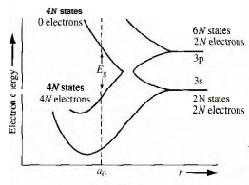

2번문제
Let T = 300 K. Determine the probability that an energy level 3kT above the Fermi energy is occupied by an electron.

3번문제
Assume that the Fermi energy level for a particular material is 6.25 eV and that the electrons in this material follow the Fermi-Dirac distribution function. Calculate the temperature at which there is a 1% probability that a slate 0.30 eV below the Fermi energy level will not contain an electron.

최선진교수님

Problem 1

Ceramic materials are generally regarded as electrical insulators. However, some of the ceramic materials exhibit electrical conductivity compatible with the metallic property. For example, TiO shows metallic electrical property, whereas TiO₂ is an electrical insulator. Explain why TiO exhibits electrical conductivity contrary to insulating TiO₂.

Problem 2
List and classify types of imperfections present in materials in terms of the dimensional properties, i.e., point (0-dimensional), line (1-dimensional), and plane (2-dimensional defects). Explain the characteristic properties of these defects.

