<박사>
재료과학

정용재교수님
영문ver.
1. The figure below is the single-component phase diagram for SiO₂.
The existence curve between liquid and cristobalite is nearly horizontal and the coexistence curve between low quartz and coesite is nearly vertical. Please explain why these slopes are so different.
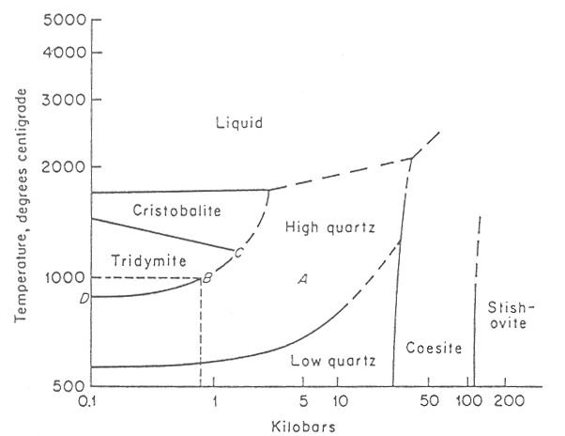

기존ver.
1. 아래의 상평형도를 보면 Cristobalite와 Liquid사이의 coexistence curve는 수평에 가깝고, Low quartz와 Coesite사이의 coexistence curve는 수직에 가깝다. 그 이유가 무엇인지 설명하시오. (주의: 온도축과 압력축의 위치를 확인하고 문제를 풀 것!)

윤종승교수님

1. Starting with the equation ${\left(\frac{∂A}{∂T}\right)}_{V}=−S$, use the fact that $−S=\frac{A−U}{T}$to show that
$$\frac{∂}{∂T}{\left(\frac{A}{T}\right)}_{V}=−\frac{U}{T^{2}}$$
where U is the internal energy, A is the Helmholtz free energy, S is entropy, T is temperature.

2. One mole of a nonideal gas is described by the virial expansion
$$P=\text{RT}\left[\frac{1}{V}+\frac{C_{2}(T)}{V^{2}}+\frac{C_{3}(T)}{V^{3}}+\text{.}\text{.}\text{.}\right]$$
If the gas is isothermally expanded from volume V₁ to volume V₂, obtain an expression for ΔA (Helmholtz free energy) for the process in terms of V₁, V₂, T, and the virial coefficients C_{n}.

최창환 교수님

- CaculateIndium has a tetragonal unit cell for which the a and c lattice parameters are 0.459 and 0.495 nm, respectively.
(a) If the atomic packing factor (APF) and atomic radius are 0.693 and 0.1625nm, respectively, determine the number of atoms in each unit cell.
(b) The atomic weight of indium is 114.82g/mol; compute its theoretical density.

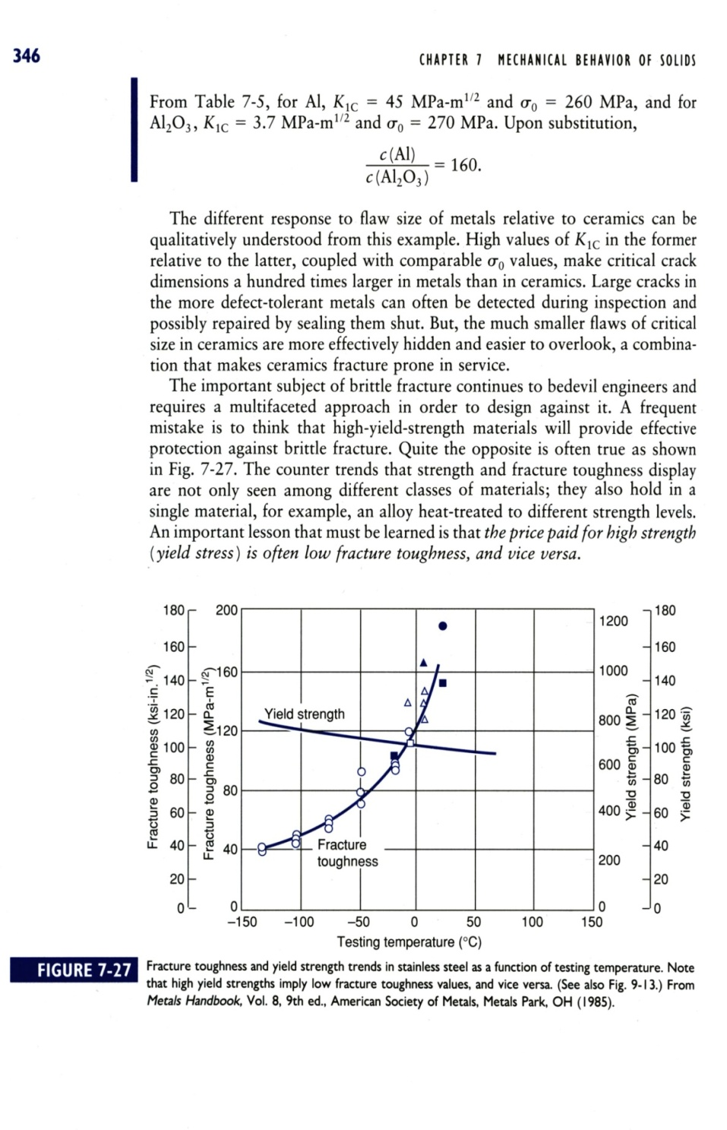
- Hanyang helicopter company requires a stainless steel that is tough enough for use in the Tropics (35°C) as well as the Arctic (-65°C). A manage asked a material engineer graduated Hanyang University to use the following data in design. At the designed use stress, the component can tolerate a surface flaw of 0.008in at the Tropics (35°C). Manufacturing inspecting equipment can only detect flaws are larger than 0.050in. Will a fracture unsafe situation arise at the Arctic (-65°C) for the same loading?
- The wear resistance of a steel shaft is to be improved by hardening its surface. This is to be accomplished by increasing the nitrogen content within an outer surface layer as a result of nitrogen diffusion into the steel. The nitrogen is to be supplied from an external nitrogen-rich gas at an elevated and constant temperature. The initial nitrogen content of the steel is 0.002 wt%, whereas the surface concentration is to be maintained at 0.50 wt%. In order for this treatment to be effective, a nitrogen content of 0.10 wt% must be established at a position 0.40 mm below the surface. Specify appropriate heat treatments in terms of temperature and time for temperatures between 475°C and 625°C. The pre-exponential and activation energy for the diffusion of nitrogen in iron are 3x10⁻⁷ m²/s and 76,150J/mol, respectively, over this temperature range. Please refer to below table of error function values if necessary.
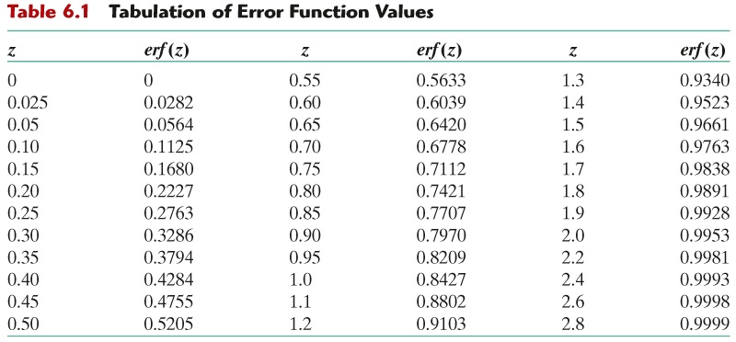

박진성 교수님

1. (a) Draw the crystal structure of NaCl.
(b) KCl has the rock salt structure with a=629 pm. Calculate its density.
(c) A compound AgX has the same crystal structure as NaCl, a density of 6.477 kgm⁻³ and a unit cell dimension of 577.5 pm. Identify X.
(Atomic Mass Information: KCl 74.6 g/mol, Ag 107.868 g/mol)

1. (a) NaCl 결정구조를 그려라
(b) KCl은 629pm의 격자거리를 갖는 rock salt 구조를 가지고 있다. 밀도를 계산하여라.
(c) AgX화합물은 NaCl과 동일한 구조를 가지고 밀도는 6.477kg/m-3이다. 이때 단위셀은 격자거리는 577.5pm이다. X는 무엇인가?
(Atomic Mass Information: KCl 74.6 g/mol, Ag 107.868 g/mol)

오누리교수님
Consider the phase diagram of an impurity in Si near the Si melting point:

Suppose that you grow a Si crystal by the Czochralski method from a liquid which contains 2 atomic % of the impurity with the corresponding phase diagram above.
- What temperature would you expect in the solid at the liquid interface in equilibrium? (You need not explain.)
- Calculate the segregation ratio for this impurity at this temperature.
- What is the effect on the temperature of the liquid near the interface of a chemically-altered liquid formed by rejection of the impurity into the liquid from the solidifying solid? (Explain in a sentence or two.)

최선진교수님

Problem 1

Answer the following questions.
- Explain the definition of Young’s modulus.
- Derive Young’s modulus related to the total force per unit area and strain at the equilibrium bonding distance (r₀). Note that stiffness (S₀) at the equilibrium bonding distance is the first derivative of the applied force with respect to the equilibrium distance (i.e., dF/dr at r=r₀), and S₀ can be approximated as spring constant by Hooke’s law.
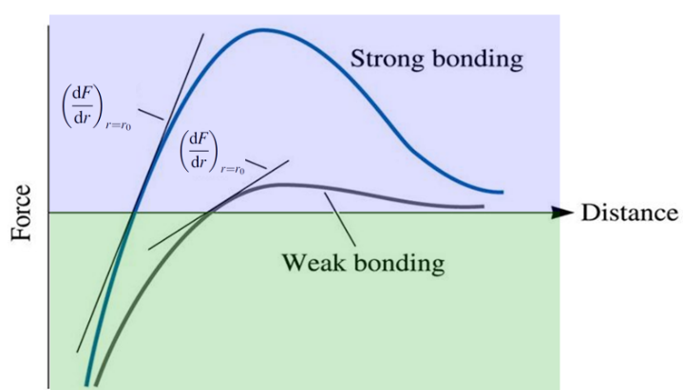
- Explain the relationship between Young’s modulus and melting temperature of materials. Draw a typical graph of Young’s modulus versus temperature of polycrystalline metal oxides.

이승용교수님

1.
(a) Based on the electronic configurations of Fe shown below, estimate the saturation flux density of magnetite ((Fe₃O₄)₈ or (FeOFe₂O₃)₈) with inverse spinel structure. The unit cell edge length of magnetite [(Fe₃O₄)₈] is 0.8397 nm.
(Bohr Magneton)=
=
Molecular weight of Fe₃O₄: 231.53 g/mol
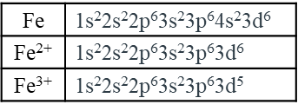
(b) Compute the velocity of light in diamond, which has a dielectric constant of 3.5 (at frequencies within the visible range) and a magnetic susceptibility of –1.00 × 10^{–5}.
Electric permittivity of vacuum
Magnetic permeability of vacuum

이종원교수님

(1) Define the van der Waals bonding including the relationship (equation) between the energy and atomic distance, and explain the difference between the van der Waals bonding and the general ionic bonding.

<박사>
금속재료

박원일교수님
기존ver.
1) List the four classification of steels and briefly describe their properties and typical applications.

2) The percent recrystallization curves as a function of time and at several temperatures for pure copper shows that recrystallization rate increases with increasing temperature (a), while for an iron-carbon alloy of eutectoid composition (0.76 wt% C) isothermal austenite-to-pearlite transformation curves shows the decreased transformation rate with increasing temperature (b). Explain why? [Hint: melting temperature of Cu: 1085 ºC, eutectoid temperature of iron-carbon alloy: 727 ºC]
(a) pure copper (b) iron-carbon alloy
Fig. 2(a)
Fig. 2(b)
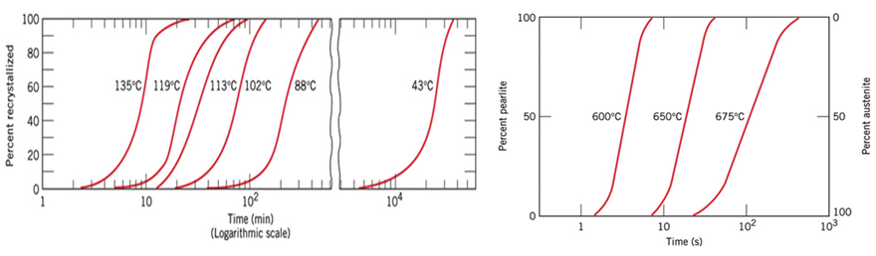

3) Determine the 'number of degree of freedom' for the cases of (i) γ phase region and (ii) γ+L phase region in the following iron-iron phase diagram.
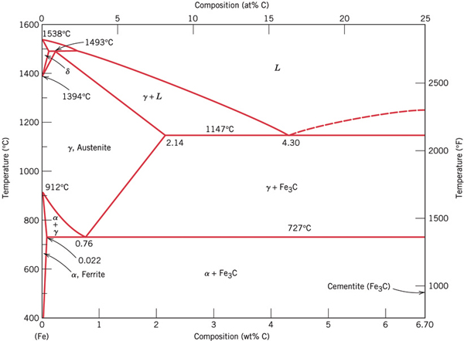

김영도교수님

영문ver.
1. Explain why the plain carbon steel cannot have bainite by continuous cooling. What is the difference of structure between bainite and pearlite?

2. Draw the microstructure of ingot when it is solidified and explain the reason. If the mold temperature is higher, what is the difference in microstructure of ingot? If the purity of the melt is higher, what is the difference in microstructure of ingot?

3. For solidification, liquid metals have to cool down to temperature far below their equilibrium freezing points before solidification begins. However, metals do not superheat to any appreciable extent before they are liquefied, whereas some supercooling occurs almost every time a metal is frozen. Explain why?

기존ver.
1.단순 탄소강에서 연속냉각에 의해서 bainite 조직을 얻을 수 없는 이유를 설명하고 bainite 조직과 pearlite 조직과의 차이를 설명하라.

2. 일반적으로 solidification을 할 때 얻어지는 잉곳트(ingot)의 미세조직을 그려보고 왜 그렇게 되는 지를 설명하라. 또한 일반적으로 주조할 때 보다 mold의 온도를 올렸을 때와 아주 순도가 높은 순금속을 solidification 할 때의 ingot의 미세조직은 어떻게 달라질 것인가?

3. 순수한 금속이 melting이 되어 액상으로 될 때 superheating정도가 solidification시에 필요한 supercooling정도에 비해 적은 이유는?

장재일교수님

- Explain (a) “constitutional supercooling” and its critical condition, and (b) Gibbs phase rule.

- Why does a metallic material with smaller grain exhibit higher strength? Describe all the possible reasons.

- We are cooling down two liquid alloys having compositions “1” and “4” respectively, and, at a certain temperature, some phases are formed as shown in the following ternary phase diagram. Schematically explain how we can determine (a) the composition of each alloy (in terms of each element, A, B, C), and (b) the relative amounts of the phases in each alloy.

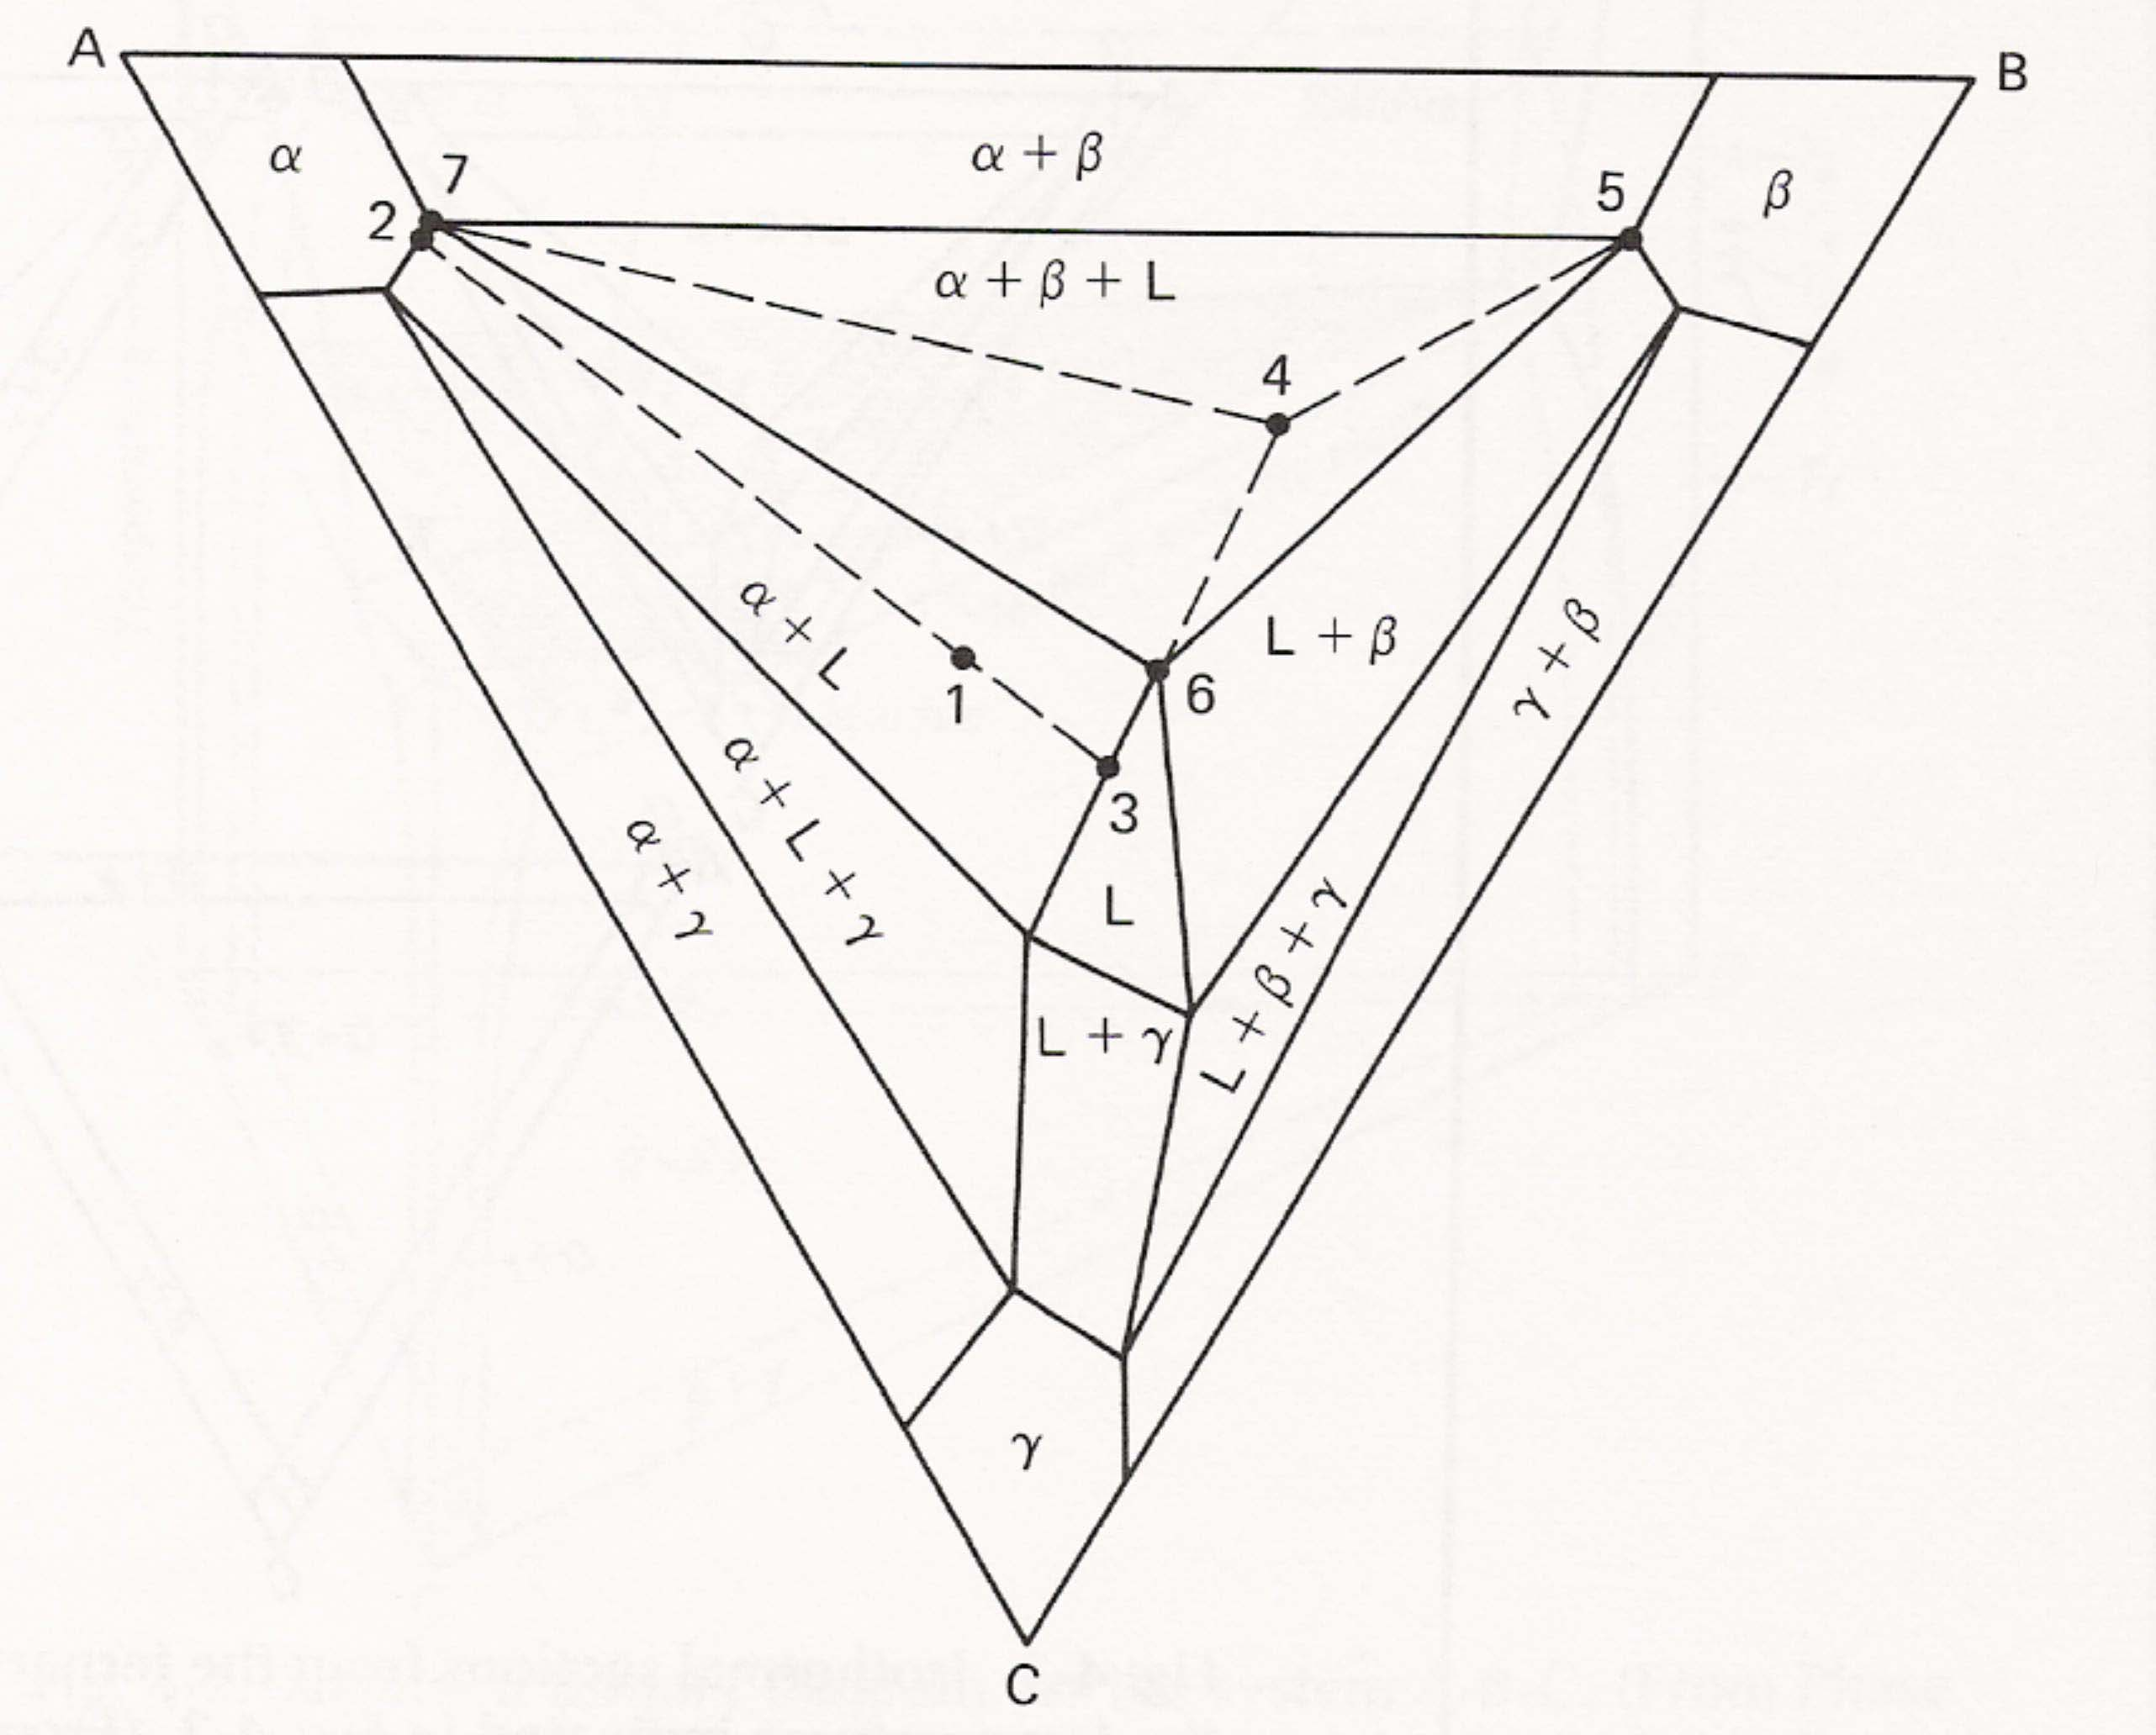

한정호 교수님

한글 version
1. 회복, 재결정, 결정립성장 과정에 대하여 그림을 활용하여 설명하시오.

2. 연성-취성 천이 온도 (ductile to brittle transition temperature; DBTT) 발생의 이유를 Yoffee diagram을 통하여 설명하시오. 더불어 충격 시험을 통하여 DBTT를 판단하는 법을 설명하시오.

3. Fe-0.4C (wt.%) 강이 A온도에서 상온으로 매우 천천히 냉각되고 있다. 이때 확산 변태만 일어나며, 마르텐사이트 및 베이나이트 변태와 같은 무확산 변태는 일어나지 않는다. 그림에 표시된 지점에서 미세조직의 변화를 나타내고, 냉각 이후 초석상과 다른상의 상분율을 계산하라.
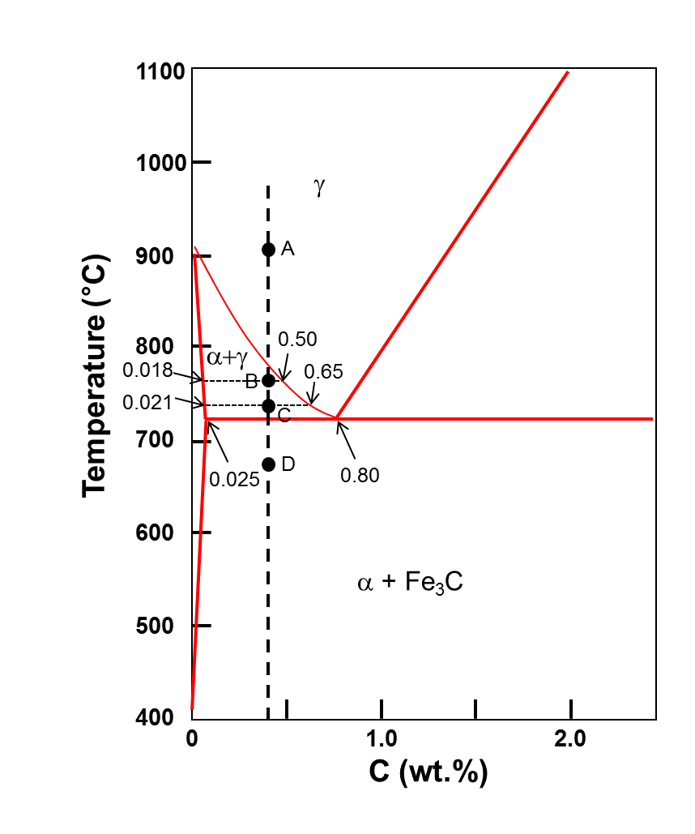
영문 version
1. Explain the recovery, recrystallization, and grain growth process using schematic diagram.

2. Using the Yoffee diagram, explain the underlying cause of the ductile to brittle transition temperature (DBTT). Furthermore, how is the DBTT determined through an impact test?

3. When the Fe-0.4C (wt.%) steel at A temperature is cooled down to room temperature with very slow cooling rate, it showed the only diffusional transformation without diffusionless transformation (martensitic and bainitic transformation). Please state the microstructural changes at the remarked positions. What is the phase fraction of both proeutectoid phase and the other phase after cooling ?

<박사>
세라믹재료

정용재교수님

영문ver.
1. For a typical metal oxide system, MO, Brouwer diagram is provided as follows. Please derive the formula for each defect concentration, with reasonable assumption, for different neutrality condition and explain the corresponding Brouwer diagram.
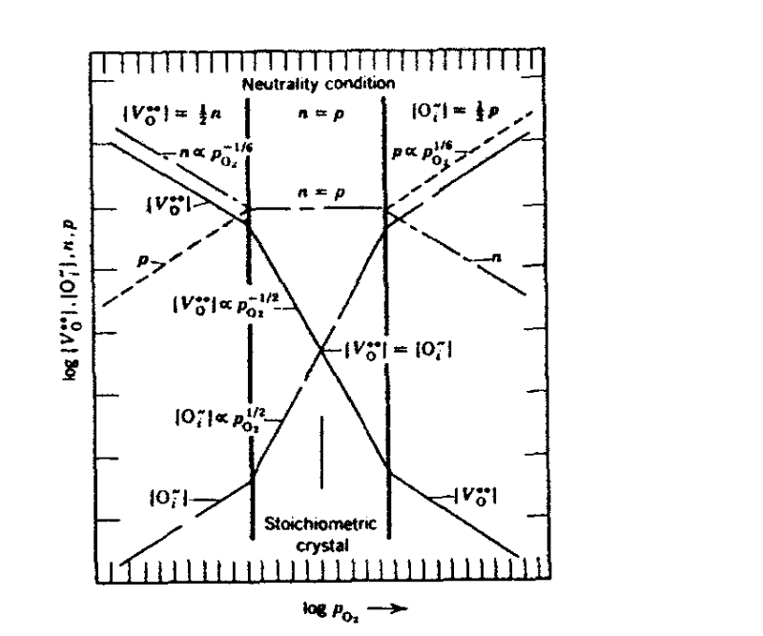

2. Please calculate 1)Schottky formation energy, 2)migration energy, and 3) the concentration of CdCl₂ using the following data.

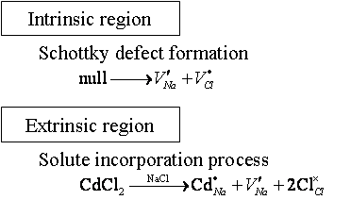
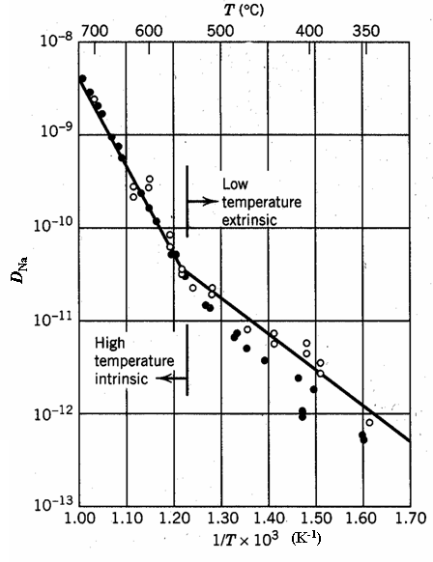

기존ver.
1. 금속산화물 MO 의 경우에 아래의 Brouwer diagram이 작성되었다고 가정하자. 적절한 가정을 통해 각각의 defect 농도 식을 유도하고, 이를 통해 아래의 Brouwer diagram을 설명하여라.

2. 다음그림으로부터 Schottky formation energy, migration energy, 그리고 CdCl₂ 의 농도를 구하여라.

신동욱교수님

영문ver.
1. Phase separation in inorganic glass materials occurs by two distinct mechanisms depending on the composition of starting homogeneous solution. Explain two mechanisms and interpret these mechanisms in the thermodynamic viewpoint.

2. Draw schematically and explain the structure of the amorphous materials such as silica glass. Describe the modifications of this structure when alkali ions are added into glass network. Also explain briefly the property changes when alkali ions are added into glass network.

기존ver.
1. 유리에서 발생하는 상분리(Phase separation)는 출발물질인 homogeneous solution의 조성에 따라 크게 두 가지 mechanism에 의하여 이루어진다. 이러한 상분리의 두 가지 mechanism을 설명하고 이러한 일이 왜 생기는지 열역학적으로 설명하시오.

2. SiO₂와 같은 비정질 재료의 구조를 개략적인 그림을 그려 설명하고 여기에 알카리 이온을 첨가할 때 발생하는 구조적인 변화를 그림으로 그려 설명하라. 또 알카리 이온이 첨가되었을 때 발생하는 물성을 변화를 설명하라.

김현우교수님

- (a) Suppose you have a germanium single crystal with dimensions 1 x 1 x 20 mm. If the crystal is doped with 10¹⁶ Sb atoms per cc and the electron mobility is 3600 cm²/V sec, which is the conductivity of the crystal? Assume all Sb atoms are ionized.
(b) Now suppose the crystal is exposed to a pulse of light such that 10¹⁴ photons are absorbed. Assuming a quantum efficiency of 1 (that is, each photon absorbed produces one conduction electron), what happens to the conductivity immediately following the irradiation?

- Aluminum oxide melts at 2300K, and the heat of fusion is 26 kcal/mole. Assuming that the internal energy and the entropy changes that take place in going from the solid to the liquid state are independent of temperature, calculate the free energy that would be released if molten Al₂O₃ were to freeze at 1800°C (say, because of undercooling).

- Consider an extrinsic semiconducting crystal oriented as shown in the following figure. The application of an electric field Ex = +62.5 V/m and a magnetic field B_{z} = +1 Wb/m² causes a positive current density J_{x} = 3.0 x 10⁴ A/m² and a positive Hall voltage E_{y} = +18.7 V/m. (The positive y face of the crystal becomes negatively charged) Determine the sign and density of the carriers in this semiconductor, and compute the mobility of these carriers.

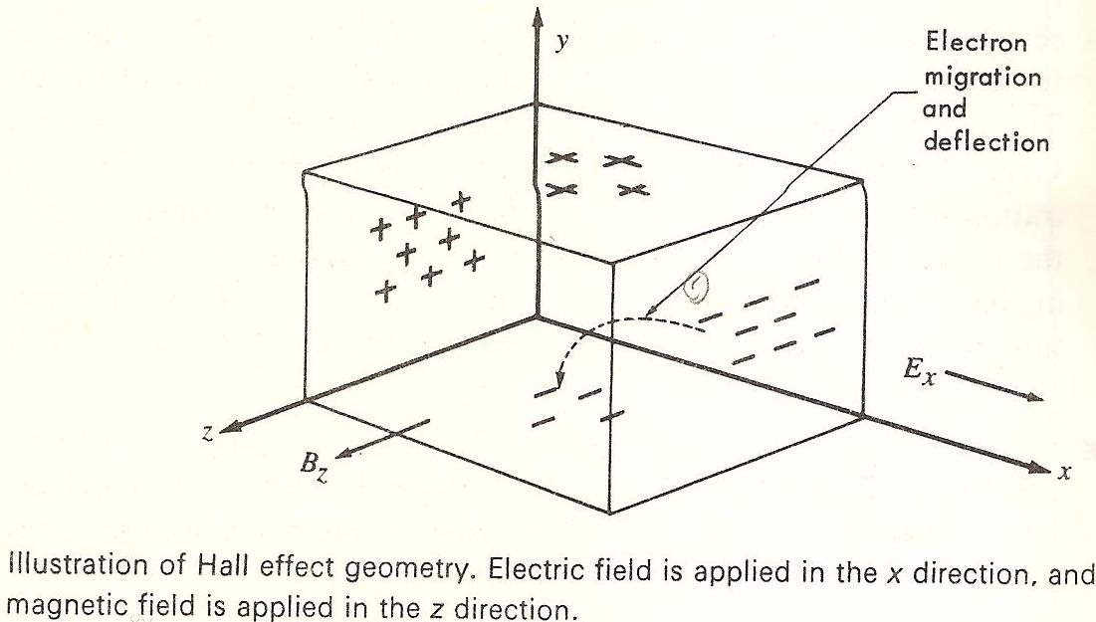

정두석교수님

영문ver.
1. Classify nonstoichiometric oxides as hypo-stoichiometry and hyper-stoichiometry and explain the dominance of one of them over the other in terms of energy.

기존ver.
1. Nonstoichiometric 산화물을 hypo-stoichiometry와 hyper-stoichiometry를 기준으로 분류하고 두 종류의 nonstoichiometry 중 하나가 지배적이 되는 이유를 에너지 관점에서 설명하시오.

임원빈교수님
1. A unit cell contains two atoms of type A with fractional coordinates (0.10, 0.10, 0.10), (0.90, 0.90, 0.90) and two atoms of type B with coordinates (0.20, 0.75, 0.40), (0.80, 0.25, 0.60). The parameters of the unit cell are a = b =5, c = 8 Å and α = β = γ = 90°. The scattering factors for the two types of atoms are tabulated below as functions of (sin θ)/λ. Find the structure factors, F_{hkl,} for (121) and all indices are positive.

(sin θ)/λ | f_{A} | f_{B}
0.0 | 6.0 | 8.0
0.1 | 5.6 | 6.8
0.2 | 3.8 | 4.7
0.3 | 2.0 | 3.4
0.4 | 1.1 | 2.5
0.5 | 0.6 | 1.8
0.6 | 0.3 | 1.3

최선진교수님

Problem 1

Answer the following questions
- How many tetrahedral and octahedral sites per unit cell in the HCP structure? Draw the unit cell structure and indicate the tetrahedral and octahedral sites.
- Identify that the ideal c/a ratio in the HCP structure is 1.633.

Problem 2

The concentration of impurities (extrinsic defect) in ceramics is usually much greater than that of intrinsic defects and the major feature of defects in ceramic is that the defects are charged (i.e., ionic defects). Answer the following questions about Kroger-Vink notation.
- Kroger-Vink notation is a useful method to express defect chemical reactions. List and explain three rules that must be satisfied for the defect chemical reactions.
- Denote defect chemical reactions of Shottky defects, Frenkel defect, and electronic defect using Kroger-Vink notation. Note that M=cation, X=anion, and null=the creation of defects from a perfect lattice.
- When aliovalent solutes are incorporated in a crystal structure, an overall charge should be compensated in a solid solution. For example, approximately 15% CaO can be incorporated in cubic ZrO₂ by producing oxygen vacancies, which make the CaO doped ZrO₂ as an ionic conductor for application in solid-oxide fuel cells. Write the defect chemical reaction when Ca²⁺ cation substitutes for the Zr⁴⁺ cation.
<박사>
물리금속

김영도교수님

영문ver.
1. A single crystal of Cu yields under a critical shear stress of about 10,000psi. Suppose that the {111}plane is slipped to the direction of <110> and tensile stress is loaded to the <100> direction, how much the tensile stress is required in order to yield a single crystal of Cu into the <110> direction in the {111} plane?

2. A compression test will be performed using single crystal with FCC structure. If the compressive axis is certain direction of pole of the (010), (011), ( 11) in stereographic triangle, determine the indices of primary, conjugate, and cross-slip system. And what will be the orientation of compressive axis in the end?

3. Generally, when low carbon steel is deformed under tensile test, sharp yield point is appeared on the stress-strain curve. What is called this phenomenon and why does it occur? What is strain aging and dynamic strain aging?

기존ver.
1. 단결정 Cu는 임계전단응력값 = 10,000psi 일 때 yielding이 일어난다. Slip이 {111} 형태의 slip면에서 <110> 형태의 방향으로 일어난다면 만일 인장축 <100>방향으로 인장응력을 가하였다면 {111} 면에서 <110>방향으로 yielding이 일어나기 위한 최소인장응력은 얼마인가?

2. Fcc 구조의 단결정 금속을 압축시험을 행하고자 한다. 이때 압축 축(axis)이 (010), (011), (11)의 pole로 이루어진 stereographic triangle 내의 어떤 한 방향이라면 이 경우 primary slip, conjugate slip 및 cross-slip system은 각각 어떻게 되겠는가? 또한 이때 압축 축은 최종적으로 어떠한 orientation을 가져야 하는가?

3. 일반적으로 저탄소강을 인장시험을 행하여 변형하였을 때 stress-strain curve에 sharp yield point가 나타나게 되는데 이러한 현상은 무엇이며 왜 일어나게 되는가? 또한 strain aging은 무엇이며 dynamic strain aging은 무엇인가?

윤종승교수님

1. The first law of thermodynamics states that energy is not created or destroyed. In full, this gives the equation:
$$ΔU+m\frac{{Δv}^{2}}{2}+\text{mg}Δh=q−w$$
In a rocket engine, superheated compressed gases are expanded against a constant pressure in such a way that ∆h and q can be considered zero and the only work done is PdV work. As well, in the reaction chamber, the initial velocity of the gases is near zero.
Thus we can say that
$$\frac{1}{2}v_{\text{exit}}^{2}=−\frac{ΔH}{m}$$
If a rocket is propelled by vaporizing lithium in an equal molar stream of helium, heating the gas to 3000 K and 100 atm in a nuclear reactor and then expanding through the rocket nozzle, calculate

a) the maximum exit velocity if the final gas temperature is 500 K and all the lithium is condensed to liquid.
Li (liq , 1 atm, 500 K) → Li (liq , 1600 K) ∆H = 22,800 joule/mole
Li (liq , 1600K) → Li (g, 1600 K) ∆H = 147,500 joule/mole.
Li (g, 2000K) → Li (g, 3000 K) ∆H = 21,200 joule/mole
For Li(g) up to 2000 K and for He at all temperatures, assume ideal gases with C_{p} = 5/2 R.
M.W. of He = 4 g/mol, M.W. of Li = 6.94 g/mol

b) If the rate of condensation is not fast enough to condense the lithium, what would be the exit velocity if the Li stays as a supercooled gas? (Assume ideal gas to 500

2. Some alloys, including ordinary structural steel display an upper and lower yield point. (25 pt)
a) Sketch a stress-strain curve for such an alloy and indicate the upper and lower yield points.
b) Give, and briefly explain, two ways in which the double yield point phenomenon may be eliminated.

3.The change in internal energy ΔU for the combustion of C₆₀(s) is -25968 KJmol-1 at 298.15 K. The heat of formation for CO₂(g) at 298.15 is -393.5 KJ mol-1 at 298.15 K.
a) What is the enthalpy of combustion ΔH for C₆₀(s) at 298.15 K?
b) What is the enthalpy of formation for C₆₀(s) at 298.15 K?

장재일교수님

- Explain why interstitial solute atoms show much higher strengthening effect than substitutional solute atoms. (Assume the material has bcc structure)

- Two edge dislocations of the same strength are arranged in an infinite crystal as shown;
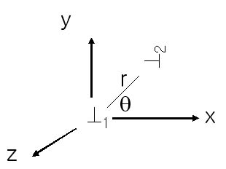
If conditions are such that only conservative motion is possible, what happens to the dislocations?
Note that the stress field of a straight edge dislocation is as follows;

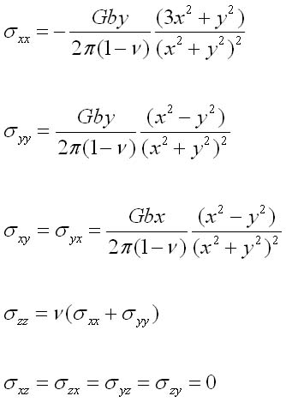

박진성교수님

1. (a) The X-rays are electromagnetic radiation of wavelength ~1 Å. Explain ‘generation of X-rays’ and ‘monochromatic X-rays’ using Cu metal target.
(b) Explain ‘Bragg’s law’ and Calculate the d and 2θ values for the 111 and 200 lines in the X-ray diffraction pattern, Cu Kα radiation (~1.54Å), of a cubit substance with a= 5.0 Å.
(c) What is the probable lattice type of crystalline substances that give the following observed reflections?
(i) 110, 220, 103, 202, 211 (ii) 100, 110, 111, 200, 210

이승용교수님

1.
(a) On the configuration of a lattice and an adjacent grain boundary in the figure below, please write the total flux ( for one-dimensional diffusion in the form of Fick’s first law.
* Assumptions: time-independent diffusion, .
(b) Explain the change in temperature-dependent contribution of the diffusivity through the grain boundary ( and the diffusivity through the lattice ( to the overall diffusivity (. A plot of temperature (1/T; x-axis) vs. diffusivity (log D; y-axis) and relevant explanations should be included for an accurate answer.
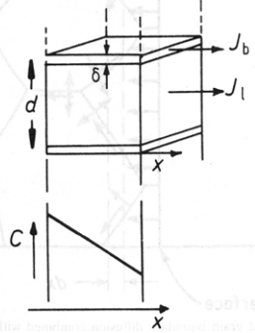

이종원교수님

(1) The phase diagram for gold and nickle illustrated below shows a two-phase field that is commonly called a miscibility gap at reduced temperatures. Explain the formation of the miscibility gap based on (i) the thermodynamic theory (regular solution) and (ii) the Hume-Rothery rule.
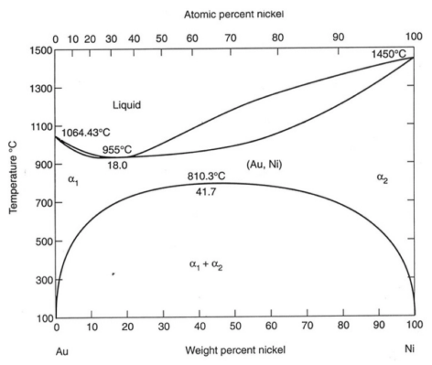

<박사>
재료공정

전형탁교수님

1. In the thin film deposition process we can classify two different methods which are chemically based and physically based. Discuss these two different methods and shows the examples of processes. And suggest which process is the most reasonable method to deposit 10 nm of uniform thin film on three dimensional structures.

2. Oxidation process is one of very important processes. Write down at least 5 factors affecting the growing of oxide and 5 application areas of these oxides.
(반도체 소자 제작 시 산화 막의 형성은 매우 중요한 공정중 하나 이다 이 산화 막을 형성하는데 영향을 주는 인자(Factor)를 5개 이상 쓰시고 또 이 산화층을 용도를 5군데 이상 쓰시오.)

3. Explain the cons and pros of Ion implantation process in semiconductor process and the lattice damage mechanism depending on the ion mass (light ions and heavy ions)
(반도체 공정에서 많이 쓰이는 Ion implantation의 장점과 단점을 각각 설명하시고 가벼운 이온과 무거운 이온의 격자 손상 mechanism에 관해 각각 설명하시오.)

안진호교수님
영문ver.
(1) Will a gas mixture containing 97% H₂O and 3%H₂ oxidize Ni to NiO at 1000°K ?
It is given that Ni + 1/2O₂ = NiO ΔG⁰_{1000K} = - 35000 cal
H₂ + 1/2O₂ = H₂O ΔG⁰_{1000K} = - 45600 cal

(2) Electron beam with 1 keV kinetic energy is injected into the metallic thin film and "diffraction" occurs. That metallic sample has cubic crystal structure and the spacing between lattice plane is 1 Å.
(a) Calculate the wavelength of the incident electron beam.
(b) Calculate the Bragg angle of the first order (n = 1) diffraction.
Given data: Electron mass m_{e} = 9.1 x 10 ⁻³¹ kg, Planck constant h = 6.6 x 10⁻³⁴ J Sec, 1 eV = 1.6 x 10 ⁻¹⁹ J

기존ver.
(1) Will a gas mixture containing 97% H₂O and 3%H₂ oxidize Ni to NiO at 1000°K ?
It is given that Ni + 1/2O₂ = NiO ΔG⁰_{1000K} = - 35000 cal
H₂ + 1/2O₂ = H₂O ΔG⁰_{1000K} = - 45600 cal

(2) 1. 1 keV의 kinetic energy를 갖는 electron beam이 다결정의 금속박막에 입사되어 회절이 일어나고 있다. 그 금속은 Cubic crystal structure를 가지고 있으며 면간 간격은 1 Å이다.
(a) 입사되는 전자의 파장을 구하라.
(b) First order (n = 1) 회절이 일어나는 Bragg angle을 구하라.
Given data: 전자의 잘량 m_{e} = 9.1 x 10 ⁻³¹ kg, Planck 상수 h = 6.6 x 10⁻³⁴ J Sec, 1 eV = 1.6 x 10 ⁻¹⁹ J

박진성교수님

1. a) Please define ‘Mean Free Path (MFP)’ in Vacuum and explain the correlation of MFP in terms of temperature and pressure.
b) Write the representative inelastic processes (4 ea) in glow discharge process (Plasma) and explain the reaction mechanism on each process.

1. a)진공에서 Mean free path (MFP) 를 정의하고 온도와 압력에 따른 MFP의 상관관계를 설명하시요.
b) Glow Discharge 과정(플라즈마생성)에서 대표적인 비탄성충돌과정 4가지를 쓰고 반응 과정과 특징을 설명하시요.

정두석교수님

영문ver.
1. Exemplify physical vapor deposition and chemical deposition techniques and discuss some pros and cons of each technique.
기존ver.
1. 박막증착을 위한 물리적 기상증착과 화학적 기상증착법의 예를 들고 각 방법의 장단점에 대해 기술하시오.

오누리교수님
You are depositing a thin film of InP on two different substrates, Si and Ge. The thermal expansion coefficients and lattice constants are:

 | Thermal expansion Coefficient °C⁻¹ | Lattice constant  nm
Si | 2.6 x 10⁻⁶ | 0.5431
Ge | 5.9 x 10⁻⁶ | 0.5658
InP | 4.6 x 10⁻⁶ | 0.5687

- Under growth conditions if the film is stress free, then upon cooling what is the sign of the stress of the InP grown on a Ge and on a Si substrate? (i.e. compressive or tensile)
- If the growth temperature is 600°C and if the film is strain free at this temperature, what is the magnitude of the strain at 20°C? (Strain is unitless.)
- If the strain in the film is determined by the lattice misfit at the growth temperature, which substrate would be the better choice as a substrate to minimize strain upon cooling? (Assume that thermal expansion strain directly offsets misfit strain.)

최선진교수님

Problem 1

Answer the following questions about thin film deposition techniques.
- The schematic illustration shows the theoretical vapor transport in the evaporation process using a surface source, wherein the film thickness can be calculated as follows:
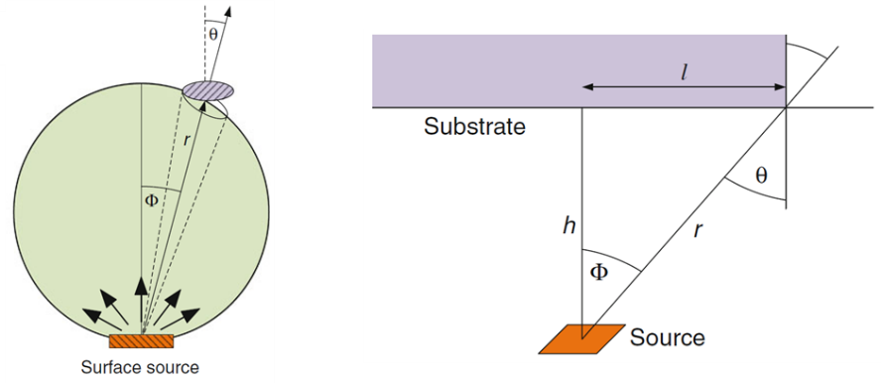
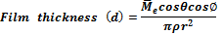
, where =total evaporated mass, ρ=film density, and r=distance from a source to a wafer.
Generally, the film thickness exhibits non-uniformity when comparing the thickness at the center and the edge of the wafer. Calculate the normalized film thickness (d/d₀) of the thermal evaporation process. Also, provide strategies in terms of wafer size (l) and the distance between the source surface and the center of the wafer to obtain uniform film thickness during the thermal evaporation process. Note that d₀ is the maximal film thickness at the center of the wafer.

- The deposition rate for the evaporation process using the surface source is expressed below:
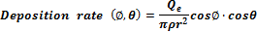
, where Q_{e}=total mass evaporation rate from a source, ρ=film density, r=distance from a source to a wafer. To obtain the constant deposition rate among wafers, draw a schematic wafer arrangement in an evaporation chamber. Also, derive the deposition rate with the wafer arrangement.

- Explain the difference between atomic layer deposition (ALD) and chemical vapor deposition (CVD) processes in terms of precursor pressure versus deposition time. Draw pressure versus deposition time curves for each deposition process.

이승용교수님

1.
(a) Compare the specific volume changes on temperature of ‘glasses’ and ‘typical crystalline materials’, by drawing a plot of temperature (T; x-axis) vs. specific volume (1/; y-axis) for the formation of glass or crystalline solids from their liquid states. Please explain each characteristic section in the plot.
(b) Explain the principle by which the toughness of tempered glass is improved. For an accurate answer, the principle of tempering and the principle of stress-based fracture of ceramic materials should also be explained together.

이종원교수님

(1) A semiconductor material has the following properties: E_{g} = 1.1 eV, N_{v} = 10¹⁹ cm^{–3}. When it is doped with 10¹⁵ cm^{–3} acceptors (>> n_{i}), construct the energy band diagram to indicate E_{F}. Calculate how many acceptors should be additionally doped to move E_{F} toward E_{v} by 0.03 eV.
(k = 8.62 × 10^{–5} eV/K, T = 300 K)

<박사>
전자재료

안진호교수님

영문ver.
(1) A silicon sample contains 10¹⁶/cm³ indium (In) acceptor atoms and a certain number of donors. The In acceptor level is 0.16 eV above E_{V} (valence level), and E_{F} (Fermi level) is 0.2 eV above E_{V} at 300K. How many (cm⁻³) In atoms are unionized ? (i.e., neutral) The Boltzmann’s constant, k, is 1.38 x 10⁻²³ J/K and the Fermi function is expressed as ;
(2) 100mWatt laser beam with λ=6328Å is illuminated onto 100μm-thick GaAs sample. The absorption coefficient at this wavelength is 3X10⁴ cm⁻¹. Assuming 100% quantum efficiency (i.e, one photon emission with one photon absorption), calculated the number of photons emitted per second through radiative recombination. Also calculate the power delivered to the sample as a thermal energy.
Given data : 1 Watt = 1 joule/sec, GaAs bandgap = 1.43 eV, E_{photon} (eV) = 1.24 / λ(㎛)

기존ver.
(1) A silicon sample contains 10¹⁶/cm³ indium (In) acceptor atoms and a certain number of donors. The In acceptor level is 0.16 eV above E_{V} (valence level), and E_{F} (Fermi level) is 0.2 eV above E_{V} at 300K. How many (cm⁻³) In atoms are unionized ? (i.e., neutral) The Boltzmann’s constant, k, is 1.38 x 10⁻²³ J/K and the Fermi function is expressed as ;

(2) 파장 λ=6328Å인 100mWatt 레이저 beam을 두께 100μm인 GaAs 시료에 쪼인다. 이 파장에서의 흡수계수(absorption coefficient)는 3X10⁴ cm⁻¹ 이다. 100%의 양자효율(즉, 광자 한개를 흡수하면 광자 한개를 방출)을 가정할 때, 복사성재결합 (radiative recombination)으로 인하여 매초당 방출되는 광자(photon)의 수를 구하라. 또한 열로써 이 시료에 공급되는 전력(power)은 얼마인가?
Given data : 1 Watt = 1 joule/sec, GaAs bandgap = 1.43 eV, E_{photon} (eV) = 1.24 / λ(㎛)

신동욱교수님

영문ver.
1. Draw schematically the dielectric relaxation(polarization) and loss graph observed typical dielectric materials as a function of frequency. Explain the polarization mechanisms in each frequency ranges.

2. YAG, YIG, Sapphire, Ruby, Glass are used as host materials of Laser. Explain the operational principles of solid state laser (the laser with solid state host materials doped with lasing ions), which are different from the semiconductor laser.

3. GaAs is preferred than Si as optoelectronic applications (photonic devices such as semiconductor lasers). Explain the advantages using GaAs instead of Si in terms of band structure.

기존ver.
1. 유전체에서 발생하는 유전분극현상에서 주파수의 함수로 유전상수와 유전손실을 그래프로 그리고 각 주파수 대역별로 나타나는 유전분극의 메커니즘을 설명하시오.

2. YAG, YIG, Sapphire, Ruby, Glass 등의 재료는 레이저 호스트 재료로 많이 응용되고 있다. 이와 같은 고체 레이저(host에 레이징 이온이 도핑 된 경우)의 원리를 설명하라. (반도체 레이저와는 구별됨에 유의하라.)

3. Si보다는 GaAs 같은 재료가 광반도체로 응용되고 있다. 그 이유를 밴드 구조의 차이점에서부터 설명하라.

박원일교수님

기존ver.
1) Plot and explain the electron concentration versus temperature curves for (a) silicon that has been doped with 10²¹m⁻³ of phosphorus (P), and for (b) intrinsic silicon.

2) Based on nearly free electron model, plot the Energy versus wave number (E－k) curves for two different directions (that is, E－k₁[10] and E－k₃[11] curves) in the two-dimensional square lattice of lattice parameter a.

전형탁교수님

1번문제
Discuss the X-ray generation process based on the particle and wave points of view and also explain why electron which is particle is diffracted? Diffraction studies on a polycrystalline Al sample using X-rays gives the smallest diffraction angle (2θ) of 29.5° corresponding to diffraction from the (111) planes. The lattice parameter a of Al (FCC), is 0.405 nm. If we wish to obtain the same diffraction pattern (same angle) using an electron beam, what should be the voltage needed to accelerate the electron beam? Note that the interplanar separation d for planes (h,k,l) and the lattice parameter a for cubic crystals are related by
d = a / [h²+k²+l²]^{1/2} V=(1.226nm/λ)²

2번 문제
Calculate the density of states of electron gases of one, two and three dimensions each. Electron moves freely within L, L² and L³ (L is length of each dimension).
(One allowed value of K per volume is (2π/L)³ in K space)

3번 문제
Generally most of metals exhibit the heat capacity at room temperature of 6 Kcal/mol but it goes down to zero when it cools down. Explain why?. And the contribution of electron to heat capacity is very low. Explain why?. (대분분의 금속의 열용량이 상온에서 6 Kcal/mol를 갖지만 온도가 낮아지면 0의 값을 갖는데 왜 그런지 설명하고 또 금속의 경우 전자의 영향이 열용량에 매우 적게 영향을 주는데 왜 그런지 설명하여라.)

정두석교수님

영문ver.
1. Provide a quantitative explanation of problems of metal-insulator-metal capacitors including interfacial low dielectric layers (at metal/insulator interface) in terms of total capacitance loss.

기존ver.
1. 금속-절연체-금속 구조의 캐패시터가 금속과 절연체 계면에 저유전율 계면층을 포함시 발생할 수 있는 캐패시턴스 감소 문제를 정량적으로 설명하시오.

오누리교수님

You are asked to fabricate the abrupt heterojunction with p-type GaAs with n-type AlAs. Assume the Fermi energy level is 0.3 eV above the GaAs valence band edge and 0.05 eV below the AlAs conduction band edge. Given the following data,

 | GaAs | AlAs
Band gap | 1.41 eV | 2.13 eV
Doping | 1x10¹⁵ cm⁻³ | 1x10¹⁸ cm⁻³
Electron affinity | 3.6 eV | 3.1 eV

- sketch a band edge diagram for the p-n heterojunction.
Be sure to include:
i) Values for the conduction and valence band offsets
ii) Reasonable band bending for the doping levels

- Discuss the effect if the heterojunction is graded rather than abrupt.

한태희 교수님

1. Consider compensated n-type silicon at T = 300 K, with a conductivity of and an acceptor doping concentration of 10¹⁷ cm⁻³. Determine the donor concentration and the electron mobility.

2. Assume that in an n-type gallium arsenide semiconductor at T = 300 K, the electron concentration varies linearly from to over a distance of 0.10 cm. Calculate the diffusion current density if the electron diffusion coefficient is D_{n}= 225 cm²/s.

3. For a MOSFET with V_{T}=1 V and Z=50 , L=2 , (assume an electron channel mobility =200 cm²/Vs, SiO₂ thickness = 1 and the substrate is connected to the source) calculate followings.
(a) the drain current at V_{G} =5 V, V_{D}= 0.1 V, (b) the drain current at V_{G}=3 V, V_{D}=5 V, (c) linear k_{N}, (d) saturation k_{N}

